Sean Zamastil

12/14/2024

CS-210

Mr. Rissover

Project 3 Summary

Hello, Chad Tech.

This program for Corner Grocer, is intended to track items, the purchase frequency of specific items, the frequency of histogram, and to exit the program this is sorted by a 1-4 input (as shown in Image 1). If the store carries it, it will be displayed as well as the amount purchased. (as shown in Image 2). If not, an error message will prompt the user to say the items not found (as shown in Image 3). If the user asks to print the frequence list, that will be provided (as shown in image 4). If the user asks to print the frequency histogram, that be provided (as shown in image 5).

The code itself is broken down into 2 sections, class, and a main function. The main function is the display menu itself (as shown in image 6), while the class ItemSearch works to read the input file and write output file data (as shown in image 7). This short yet simple breakdown allows for the program to be easily maintained, IE anyone else should be able to discern my thoughts, and how I’ve written my code. As well as making further improvements/implementations later more accessible.

Overall, while this program might be simplistic it effectively and efficiently collects data, reads and writes data efficiently without drawing too much memory, and performs all the tasks asked while maintaining simple yet professional at the same time. Hopefully this program does well.

Best Regards,

Sean Zamastil.

(images 1-7 below)

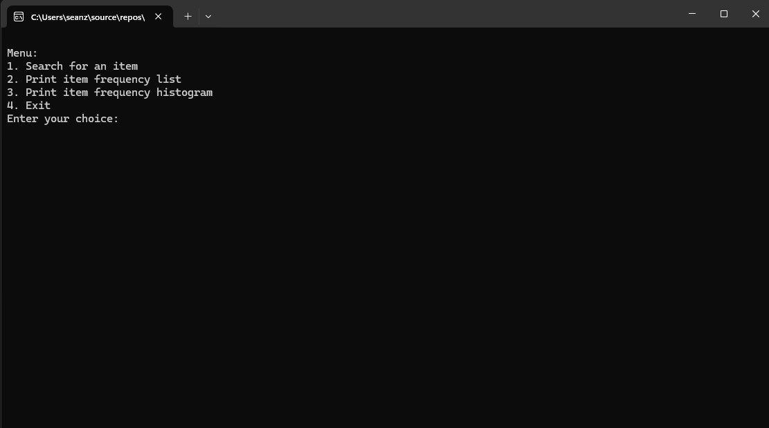

(image 1)

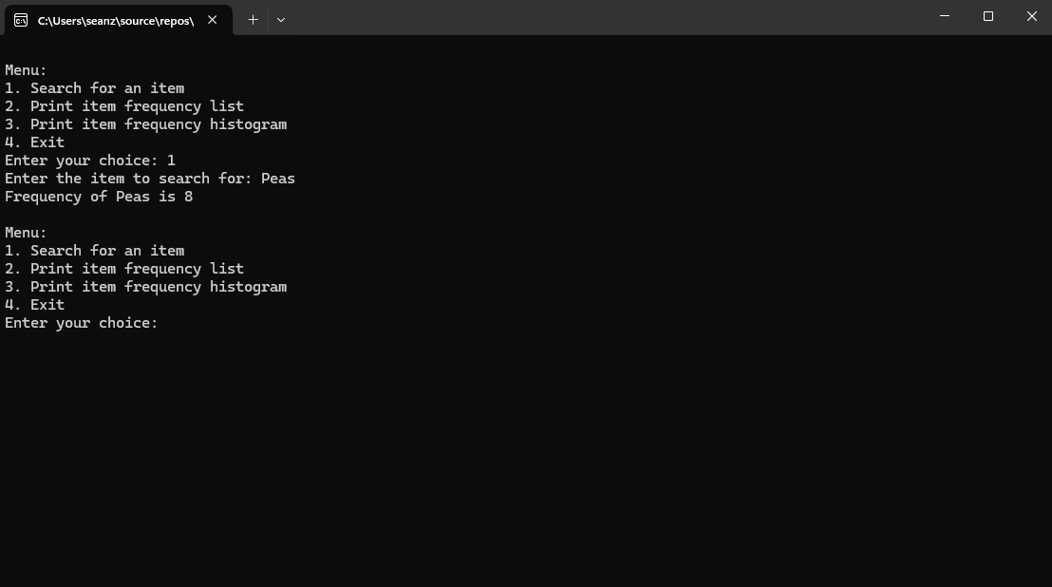Image 2

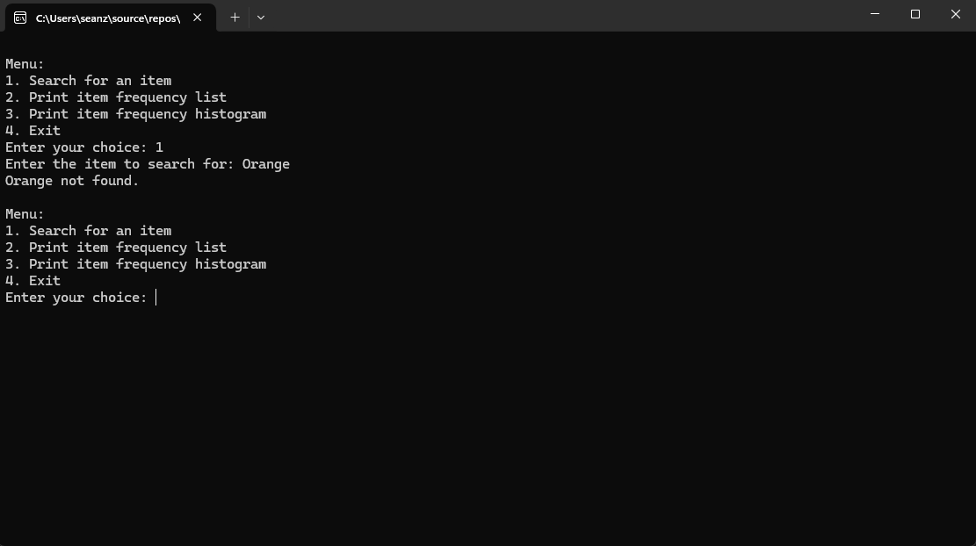Image 3

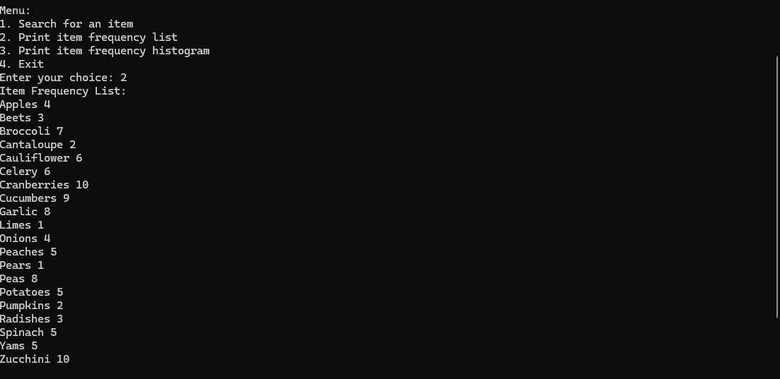Image 4

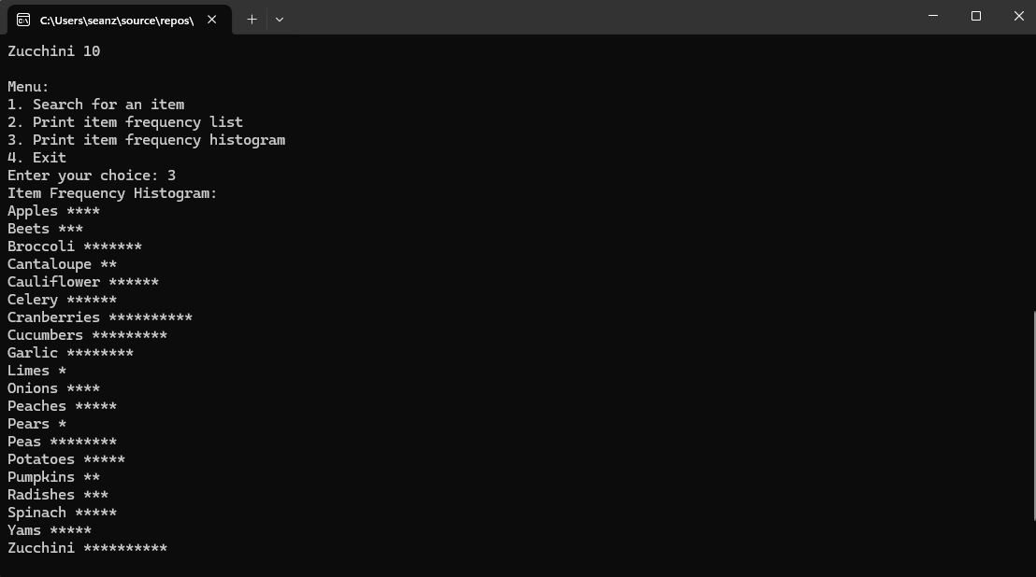Image 5

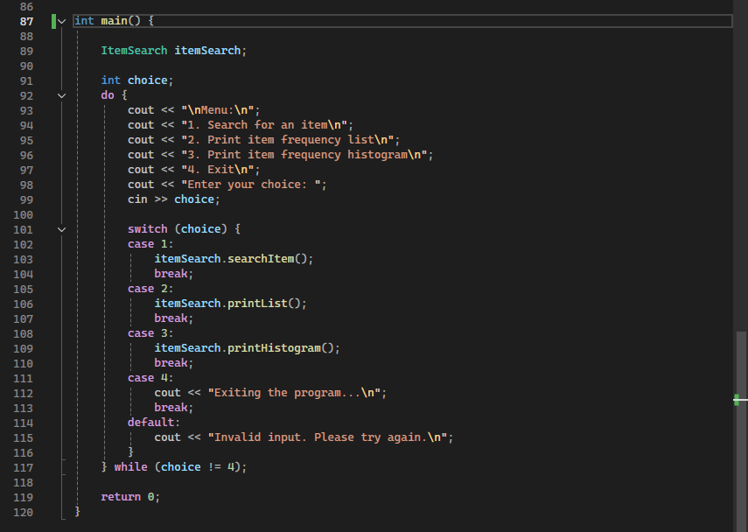Image 6

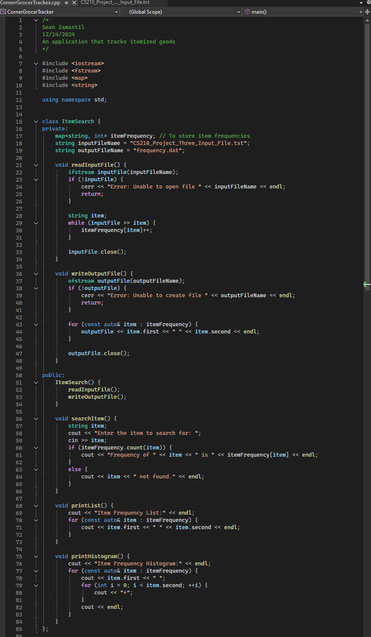

Image 7